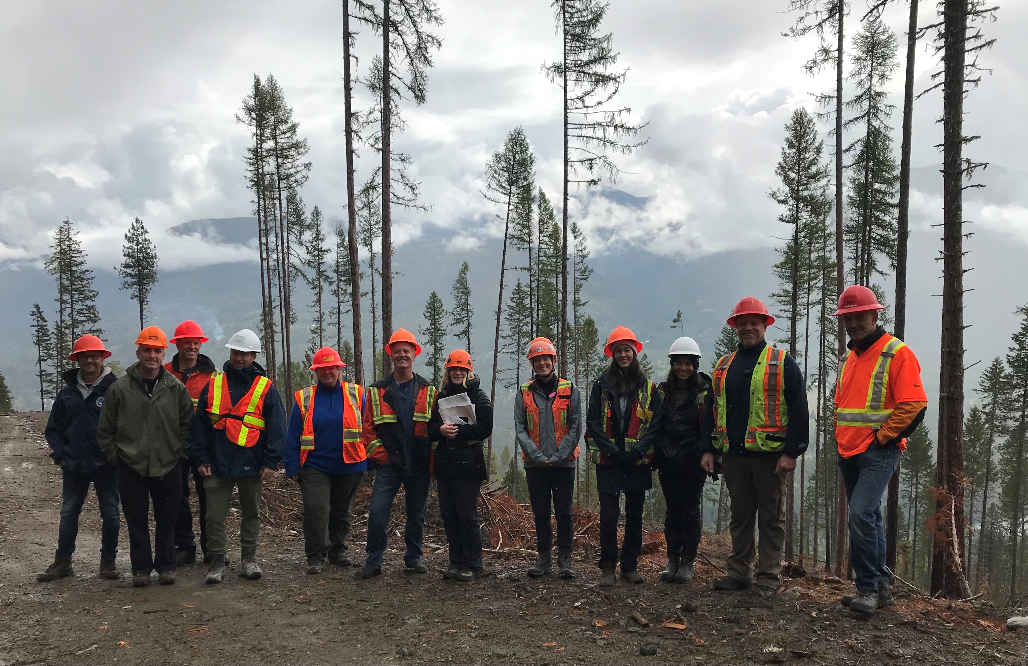

Kootenay Business Area Facts
BC Timber Sales (BCTS) is a stand-alone organization within the Ministry of Forests Lands and Natural Resource Operations. BCTS was established on June 20th, 2003 to develop Crown timber for public auction to establish market price and cost benchmarks, and to capture the value of the timber asset for the public. Kootenay Business Area Timber Sales Office is located in Nelson, with field teams located in Castlegar/Nakusp, Cranbrook, Grand Forks and Nelson.
The Kootenay Timber Sales Office has contributed to the success of BCTS through the following accomplishments over the past 17 years.

Economic Prosperity  *Estimated annual average based on Planned Harvest | Sustainable Resource Development  # Trees Planted 62,461,974  Area Planted 45,429 ha  Area Brushed 5,883.3 ha  Area Site Prepared 10,629 ha  Roads Deactivated 459.6 km  Excellence  Environmental Management System  Sustainable Forest Management (SFI) Certification  SAFE Certification  LEAN Initiative Implemented
  Volume Offered | 19,848,925 m3
  Volume Sold | 17,920,686 m3
  Volume Developed | 19,253,253 m3
  Volume Harvested | 15,758,713 m3
  Roads Built | 854 km
  Bridges & Major Structures Installed | 150
  Contracts Issued | 3088
  Contractors | 980
  Annual Direct Jobs * | 1120
  Annual Indirect Jobs* | 709

